8-1 Assignment: Data Aggregation Pipeline

Cristiano Miranda
Southern New Hampshire University
CS-340: Client/Server Development
Professor Badam
26 April 2026

8-1 Assignment: Data Aggregation Pipeline
Step 1: Importing all Data from the company.json file.
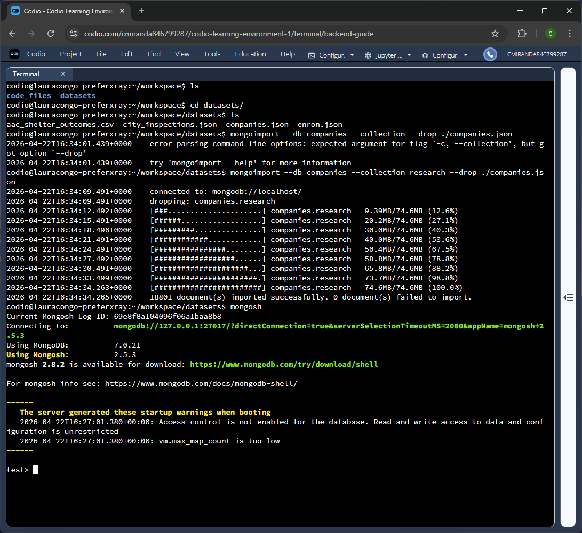
Figure 1A – Using the mongodb import command and the appropriate flags to import data from a JSON file into a new database named “companies” and into a new collection named “research.”
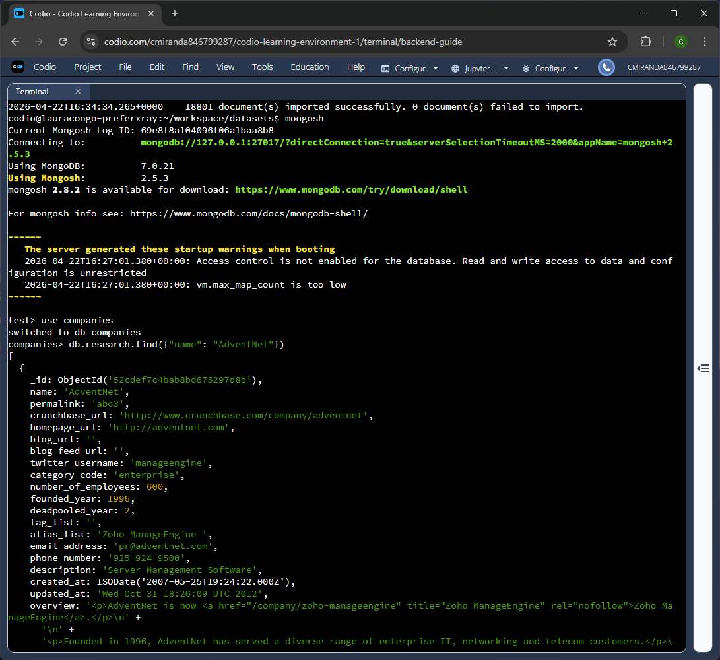
Figure 1B – Validating the import command by running a find query that searches for all entries with the name “AdventNet.”
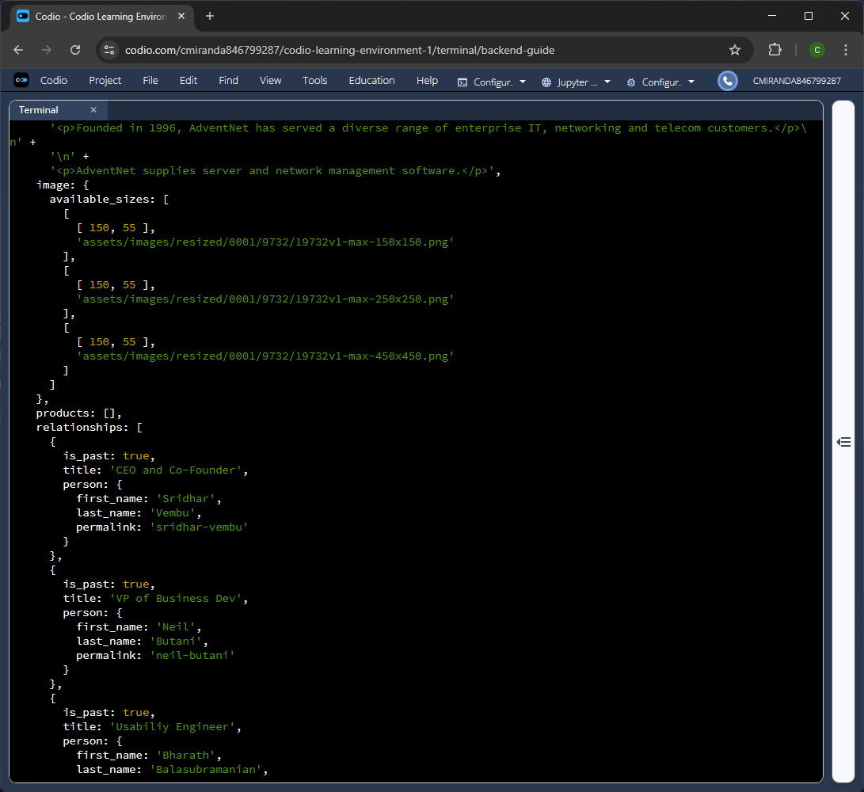
Figure 1C – Continuation of the find query results.
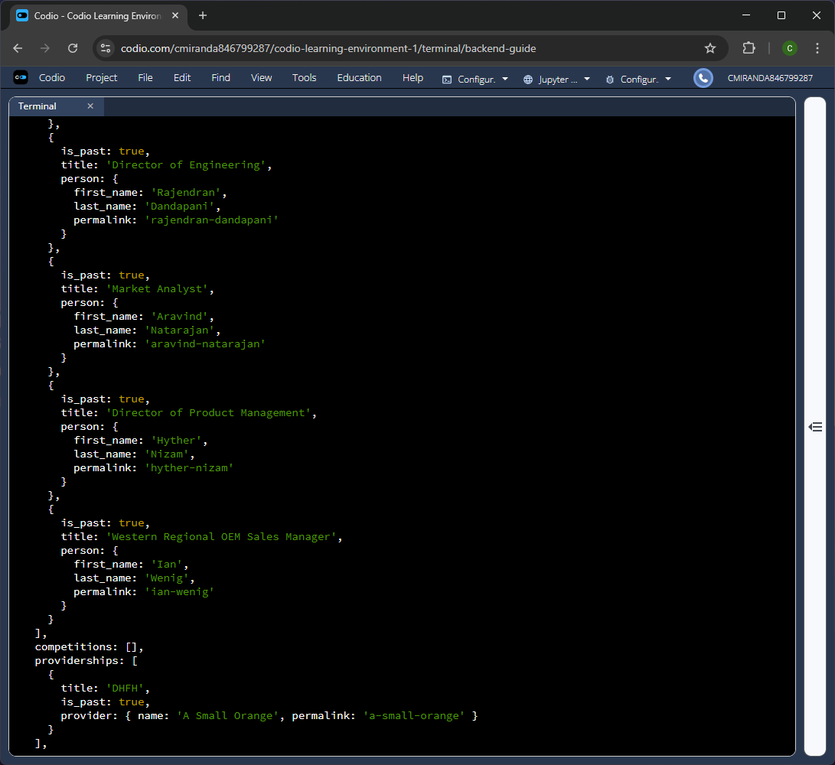
Figure 1D – Continuation of the find query results.
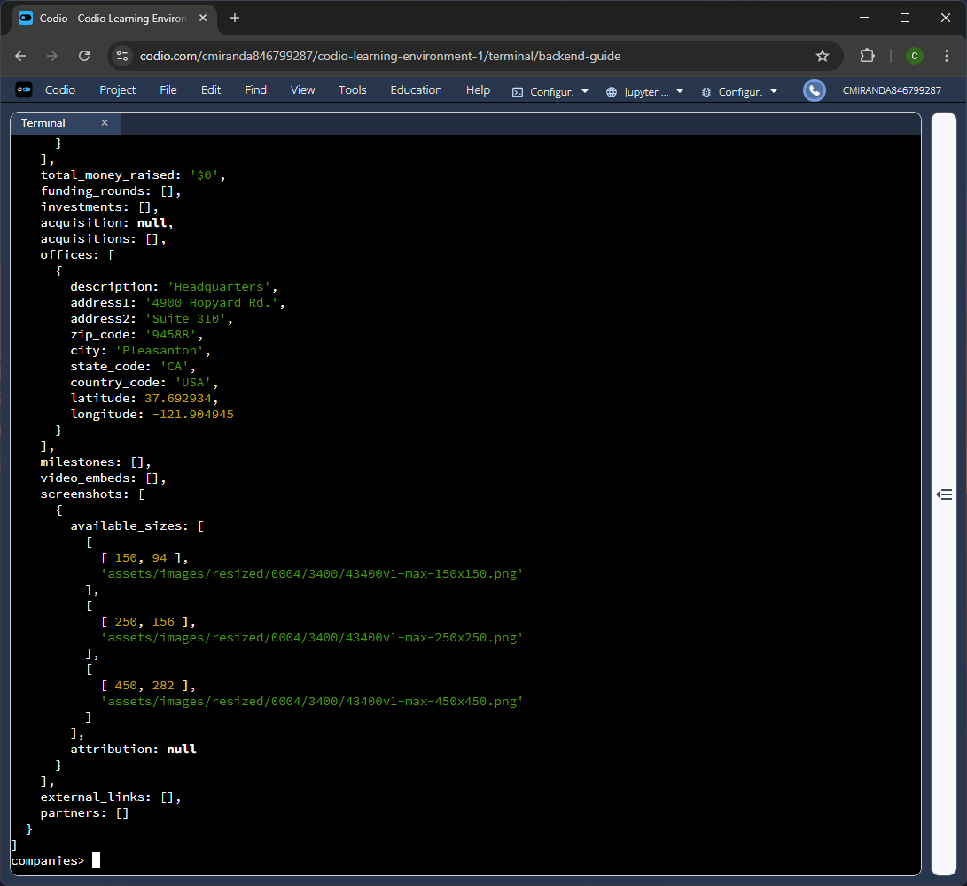
Figure 1E - Continuation of the find query results.
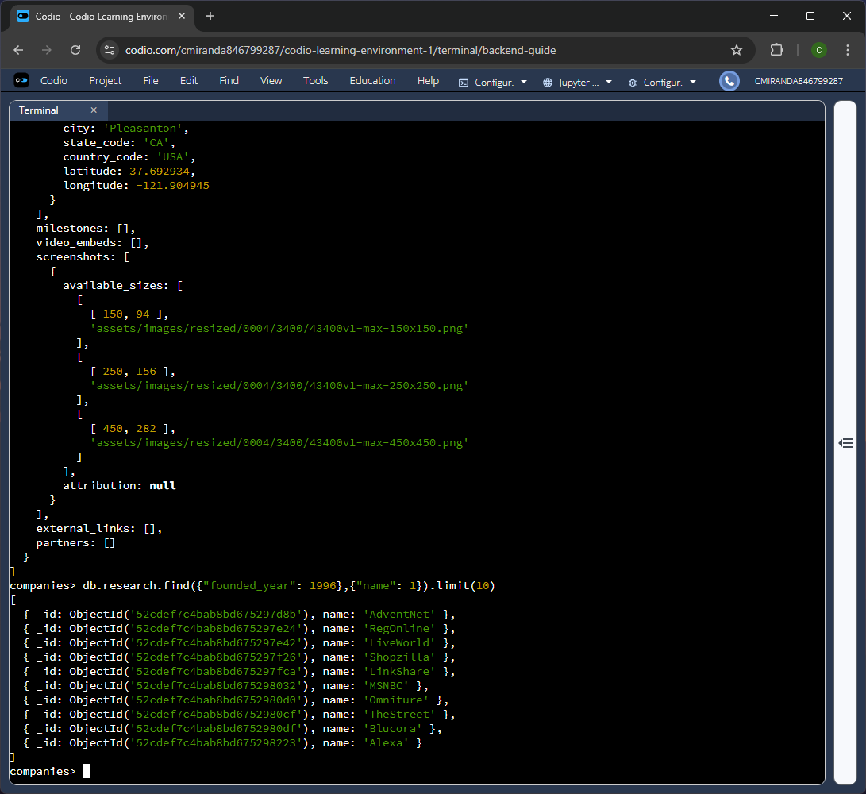
Figure 1F – Further validation of the import command by using another find query to return the first ten entries in name and id only.

Step 2: Using Aggregation to Conduct Complex Queries
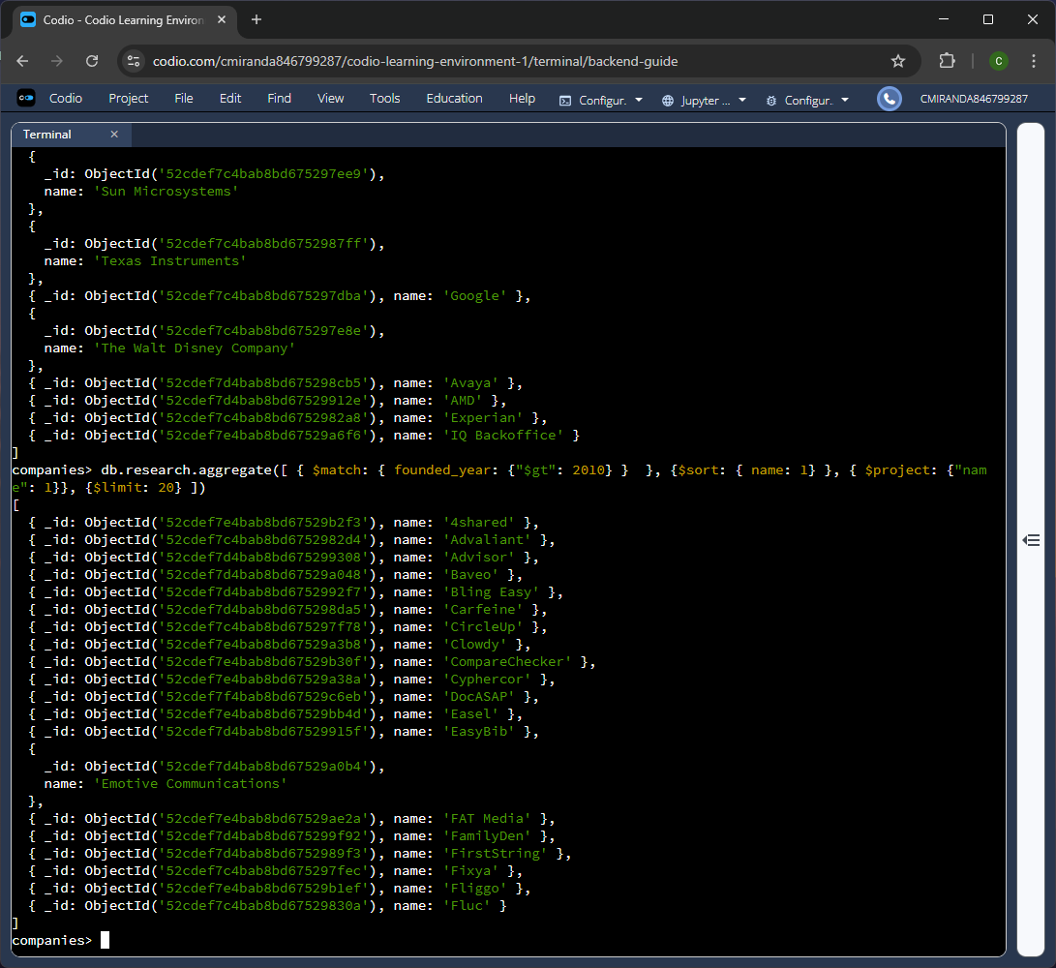
Figure 2A – Using aggregation to find the first 20 entries in which their founded year is after 2010, and the returned results are listed alphabetically. Also, only the name and id are displayed for each entry.
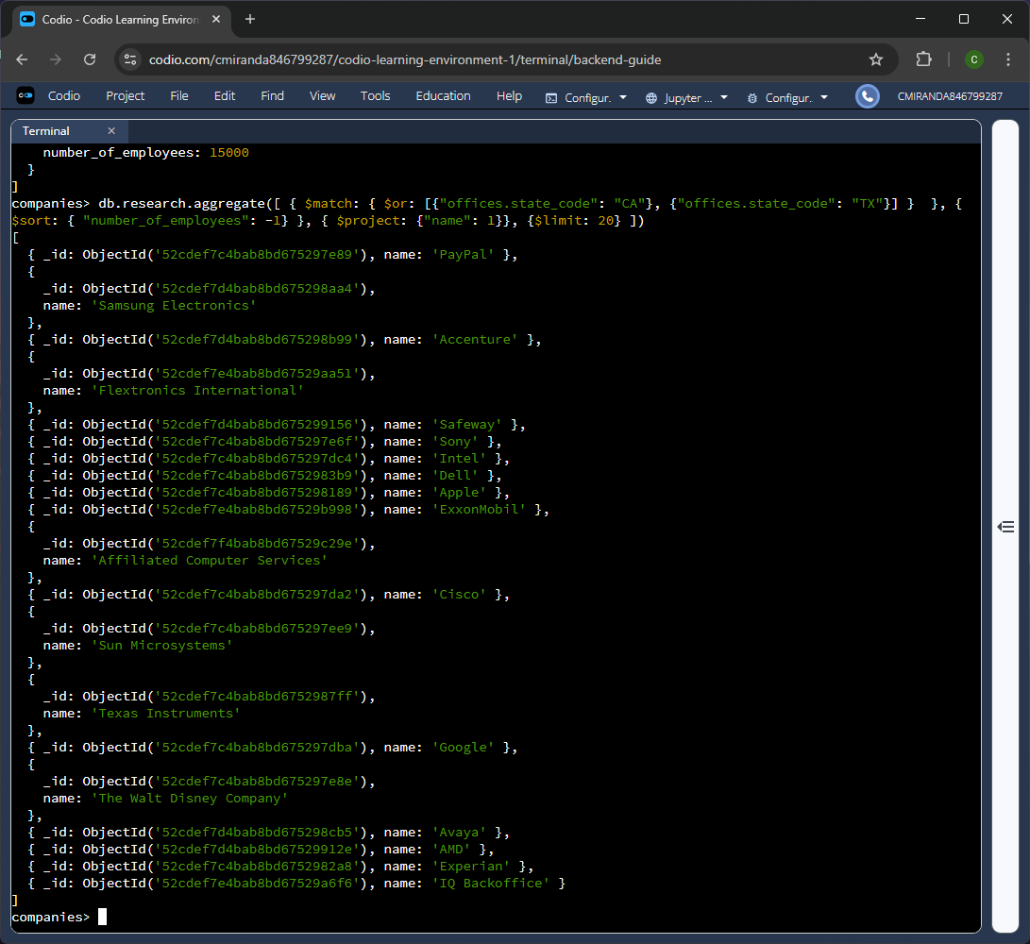
Figure 2B – Using aggregation to find the first 20 companies that have offices in either California or Texas, and the results are sorted by the number of employees at each company starting with the highest. Also, only the name and id are displayed for each entry.

Step 3: Using the Aggregation Pipeline to perform Complex Queries.
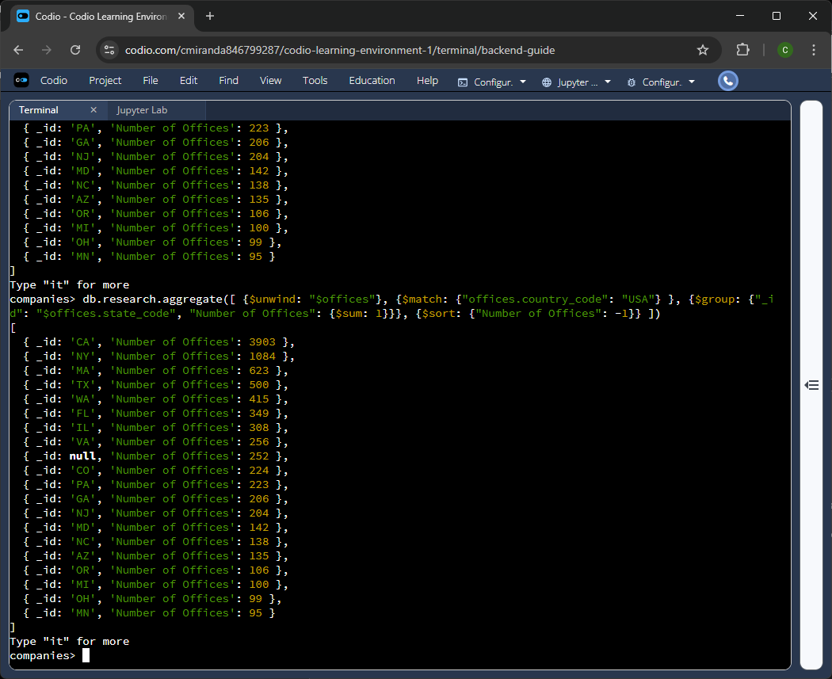
Figure 3A – Using aggregation to filter and count the number of offices for each state in the United States only.
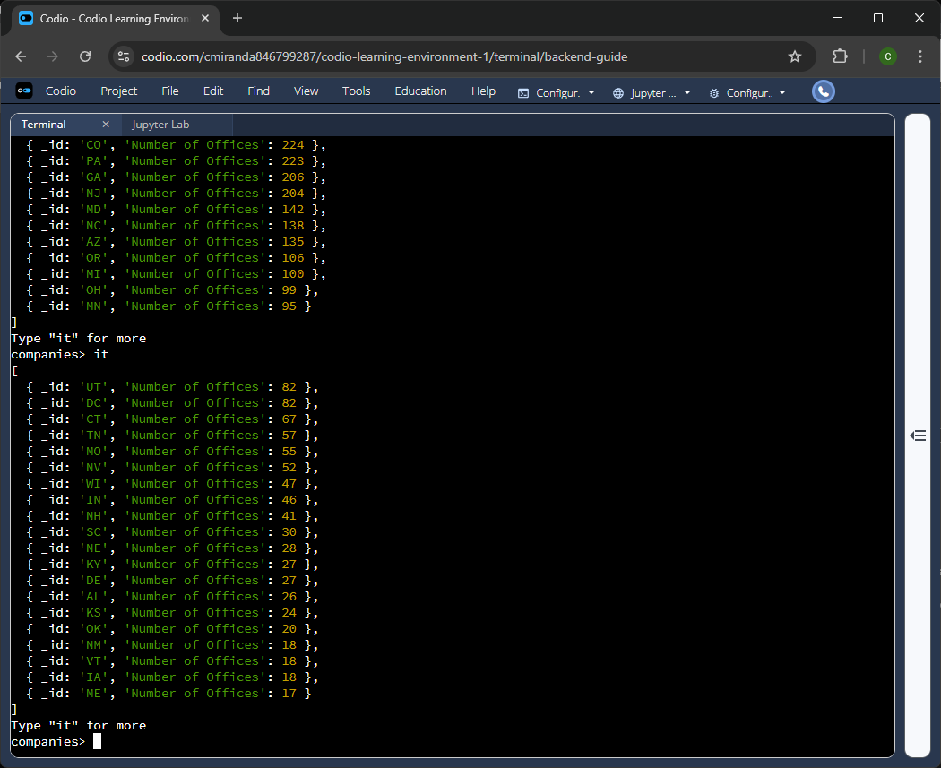
Figure 3B – Continuation of the aggregation query results.
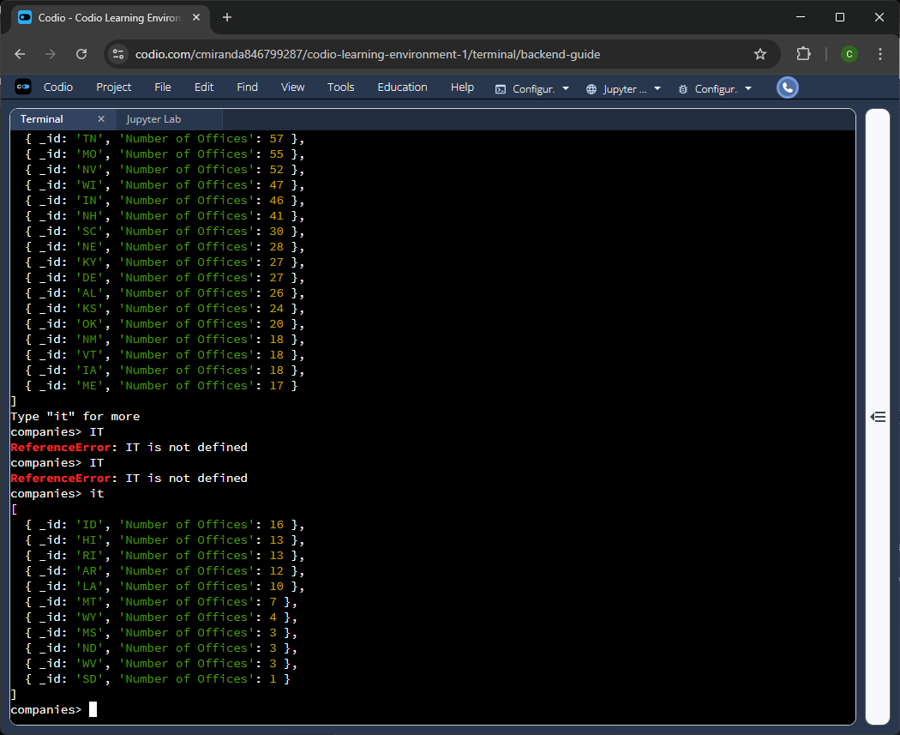
Figure 3C - Continuation of the aggregation query results.
Aggregation is used to determine the total number of offices in each state within the United States. The first step for this aggregation pipeline is to empty all office arrays so that the separate offices can be viewed individually, as this is necessary to ensure that each office is properly accounted for and accessible during the count. Failing to perform this step would result in counting arrays of offices rather than the individual offices within all arrays, meaning that each array is tallied rather than the offices within it. The second step is to filter all entries to include only those whose offices are in the United States. Performing this step is essential to ensuring that only offices confirmed to reside in the United States are counted; otherwise, offices in other countries would be counted, and even null entries would be added to the final count. The next stage is the most important: the grouping stage, in which the various offices are grouped by state code, and entries are tallied for each state code. The final step is the sorting stage, in which the results are sorted by the total number of offices found for each state code. To accomplish this, the field defined during the group stage, "Number of Offices," is sorted in descending order, with the highest value first.

